#Setup For raspberry Pi 4 Model B

1.Install Ubuntu 20.04 server

2.Setup Aircard module or LTE module (normally eth1)

1. Plug the LTE module to Usb port
2. After first login run
   1. sudo dhclient eth1
   2. The internet connection will be online
   3. sudo apt-get update
   4. sudo apt-get install python3-pip
3. Create setup eth1 service for auto connect to the Internet
   1. cd
   2. vim set_eth1.sh
   3. See detail in set_eth1.sh in the same google drive folder
   4. cd /etc/systemd/system
   5. sudo vim start-setup-eth1.service
   6. See detail in start-setup-eth1.service in the same google drive folder
   7. sudo systemctl enable start-setup-eth1.service
   8. sudo reboot

3.Install all needed packages and repos (See in Installer-script Folder)

Note: for easiest way to install ,Copy installer-script folder to Raspberry pi

1.copy installer-script folder to usb drive

2.plug usb drive to raspberry pi

3.cd /media

4.sudo mkdir usb

5.sudo fdisk -l

6.From above command you will see all devices find your usb drive ex. /dev/sda1

7.sudo mount /dev/sda1 ./usb

8.cd usb

9.At this moment you will see all folders and files in your usb drive

10. sudo cp -a /installer-script ~/installer-script

11. cd

12.For now installer-script will be copied to home/ubuntu directory which is the startup directory

13.you can run all installation script and can edit script, services and copy it to wanted destination directory

4.Enable uart 5 on Raspberry pi 4 gpio on pi 32-34

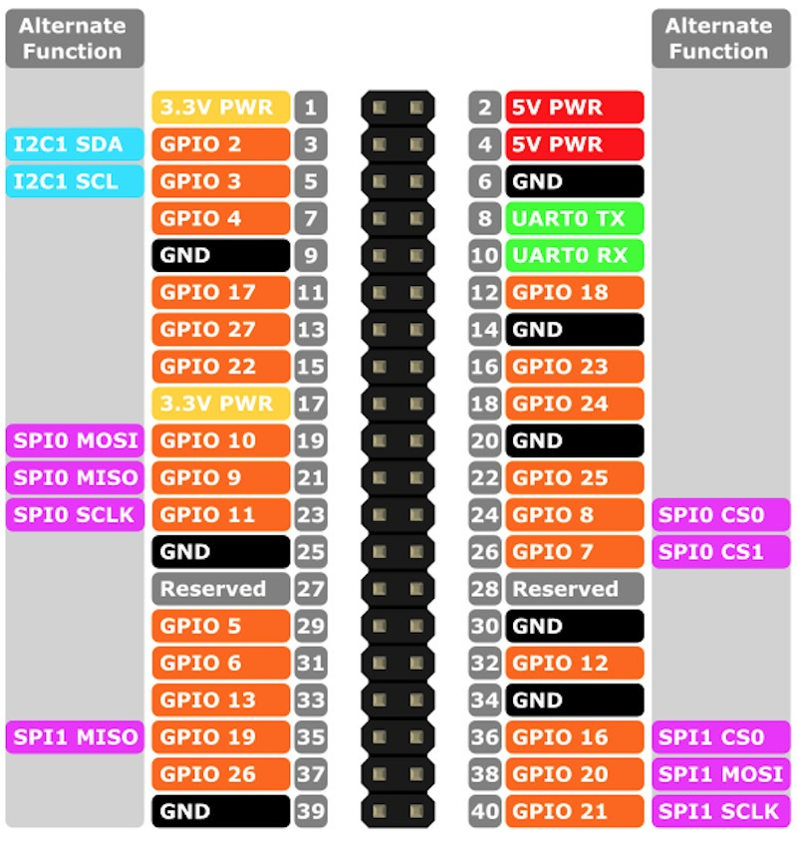

GPIO 12 pin 32 = tx

GPIO 13 pin 33 =rx

1.Disable serial-getty@ttyS0.service

sudo systemctl stop serial-getty@ttyS0.service

sudo systemctl disable serial-getty@ttyS0.service

sudo systemctl mask serial-getty@ttyS0.service

2.Setup udev rules

cd /etc/udev/rules.d/

sudo touch 10-local.rules

sudo vim 10-local.rules

*Add all content below to this file and save

KERNEL=="ttyS0", SYMLINK+="serial0" GROUP="tty" MODE="0660" KERNEL=="ttyAMA0", SYMLINK+="serial1" GROUP="tty" MODE="0660"

KERNEL=="ttyAMA1", SYMLINK+="serial2" GROUP="tty" MODE="0660"

* Reload udev rules run

sudo udevadm control --reload-rules && sudo udevadm trigger

3. Add user to tty group run

sudo adduser ubuntu tty

4.Delete console=serial0,115200 in /boot/firmware/cmdline.txt and save

cd /boot/firmware/

sudo vim cmdline.txt

5.Add newline dtoverlay=uart5, dtoverlay=miniuart-bt and dtoverlay=disable-bt to /boot/firmware/config.txt (I put it right under the cmdline=cmdline.txt line)

cd /boot/firmware/

sudo vim config.txt

Below cmdline=cmdline.txt

Add new line for each below contents (note: do not press space and/or tab key)

dtoverlay=uart5

dtoverlay=miniuart-bt

dtoverlay=disable-bt

6.sudo reboot